A simple java application (Building the java project with maven)

Step 1: Setup the project,

* create a directory structure like this

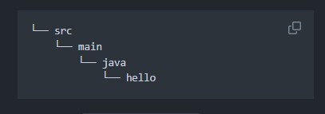

By running “mkdir –p src/main/java/hello”

Setp 2: within the src/main/java/hello create two new files

“HelloWorldJava.java” and “Greeter.java”

* “src/main/java/hello/HelloWorld.java”

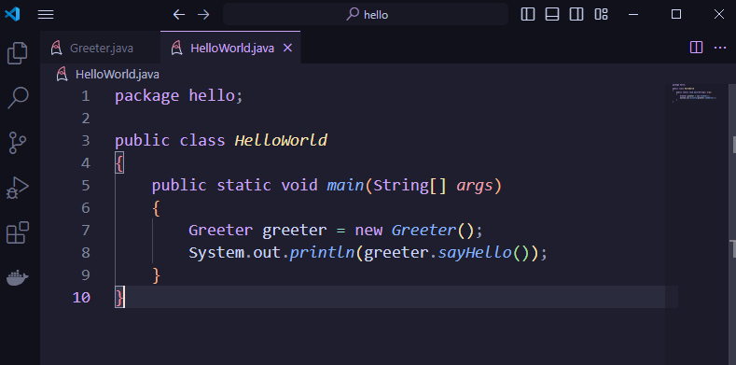

* “src/main/java/hello/Greeter.java”

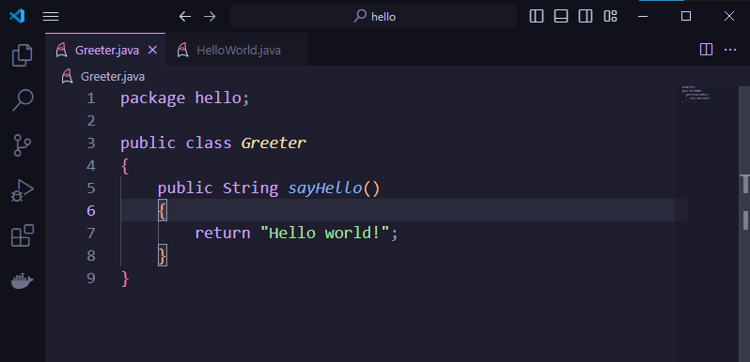

Setp 3: Define Maven Build

Create pom.xml file in root directory.

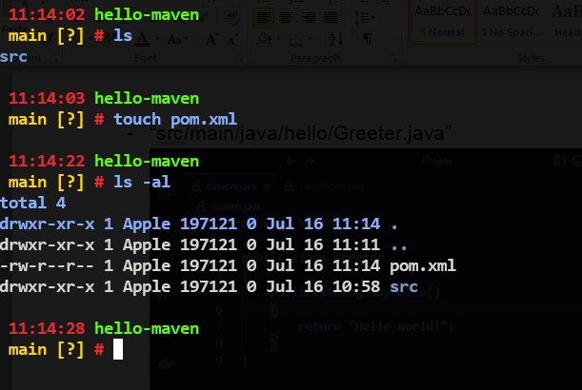

Add the following contents:

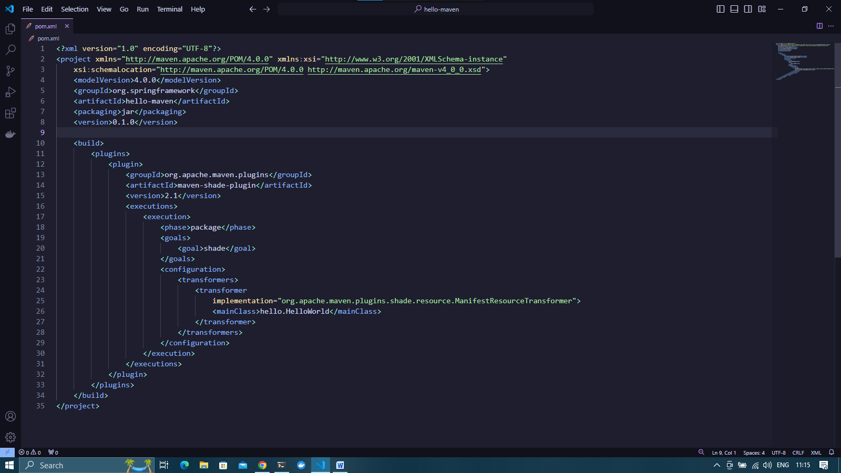

Setp 4: Build and compiling

* mnv compile : this will run Maven, telling it to execute the compile goal. When its’s finished you should find the compiled .class files in target/classes directory.

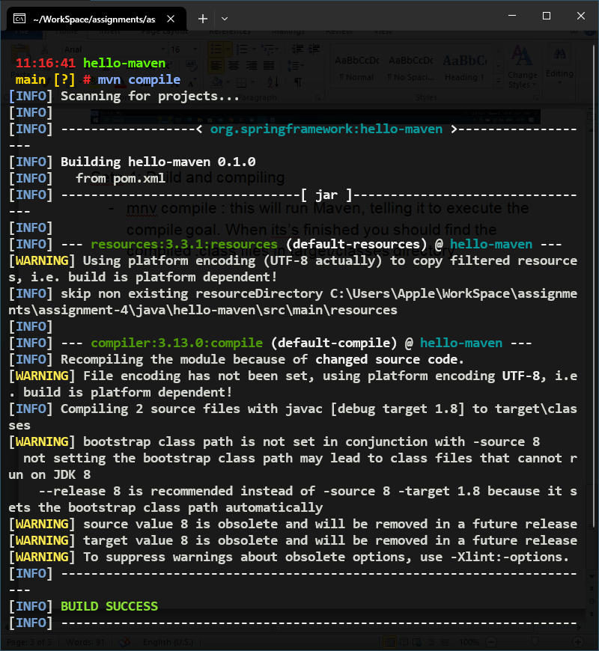

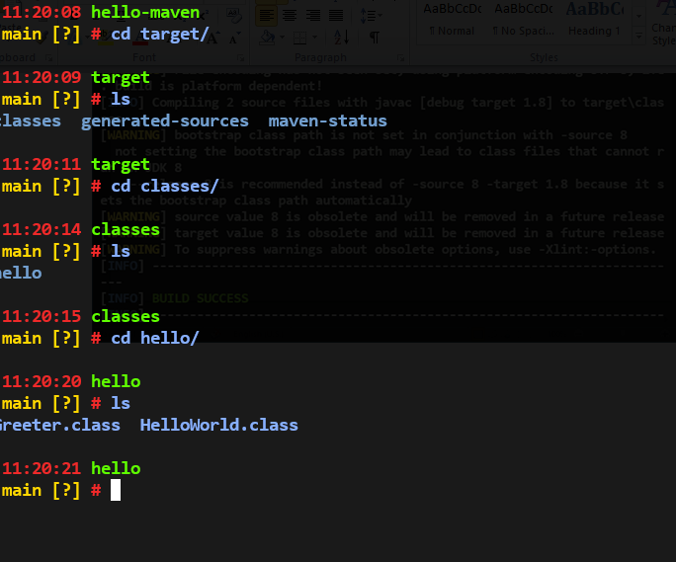

* mvn package: compiles the java code run any tests, and finish by packaging the code up in JAR file.

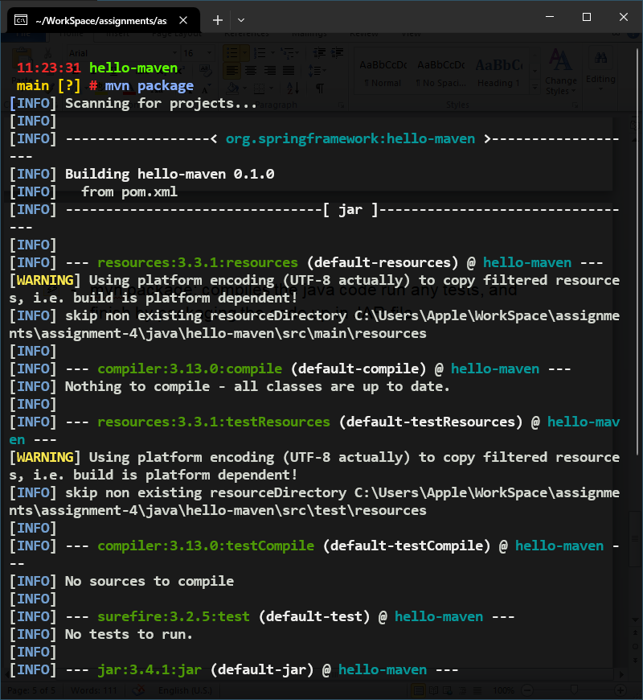

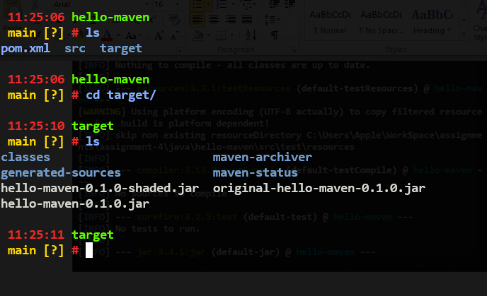

* mvn install : the install goal will compile, test, and package projects code and then copy it into the local dependency repository.

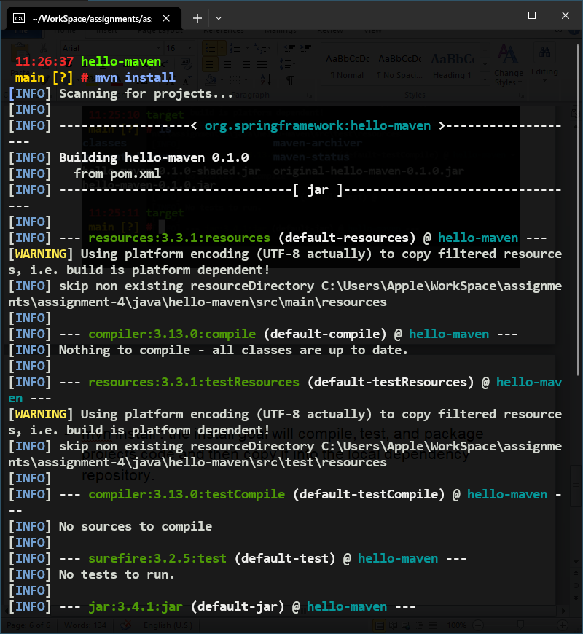

Step 5: Running the project

Run the following command : “java -cp target/hello-maven-0.1.0.jar hello.HelloWorld”

